ERD DIAGRAM:

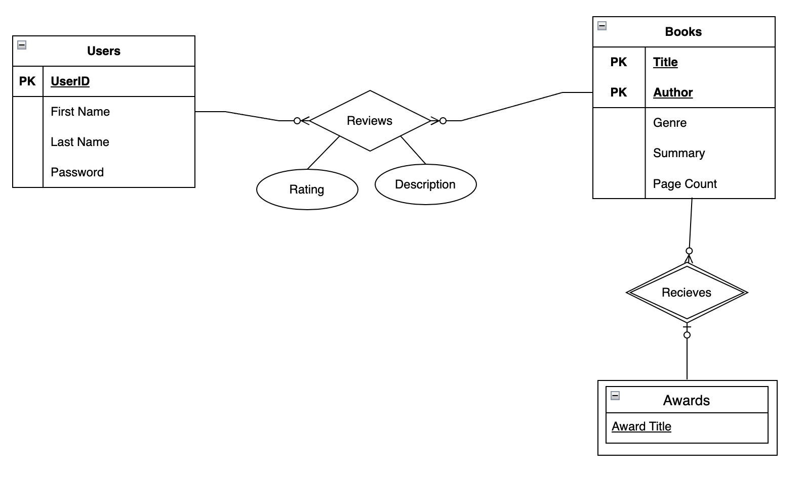

WEBSITE:

